**AVL Tree**

AVL tree is a self-balancing binary search tree in which each node maintains extra information called a balance factor whose value is either -1, 0 or +1.

## Balance Factor

Balance factor of a node in an AVL tree is the difference between the height of the left subtree and that of the right subtree of that node.

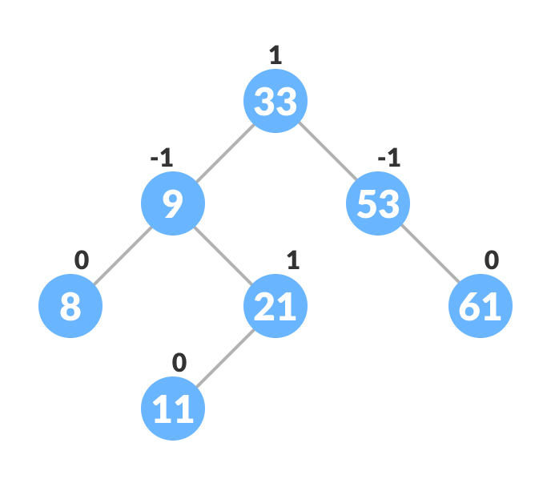**Balance Factor = (Height of Left Subtree - Height of Right Subtree) or (Height of Right Subtree - Height of Left Subtree)**

The self-balancing property of an AVL tree is maintained by the balance factor. The value of balance factor should always be -1, 0 or +1.

## Operations on an AVL tree

## Rotating the subtrees in an AVL Tree

### Left Rotate

In left-rotation, the arrangement of the nodes on the right is transformed into the arrangements on the left node.

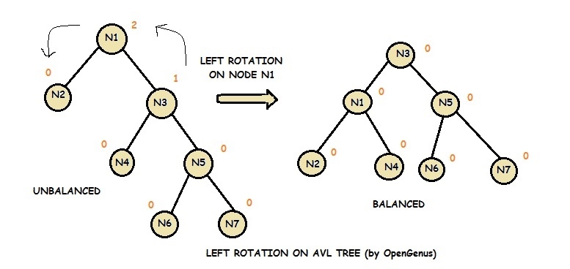

## **Complexity**

|  |  |  |
| --- | --- | --- |
| **Algorithm** | **Average case** | **Worst case** |
| Space | o(n) | o(n) |
| Search | o(log n) | o(log n) |
| Insert | o(log n) | o(log n) |
| Delete | o(log n) | o(log n) |

## **Operations on AVL tree**

|  |  |
| --- | --- |
| **Operation** | **Description** |
| [Insertion](https://www.javatpoint.com/insertion-in-avl-tree) | Insertion in AVL tree is performed in the same way as it is performed in a binary search tree. However, it may lead to violation in the AVL tree property and therefore the tree may need balancing. The tree can be balanced by applying rotations. |
| [Deletion](https://www.javatpoint.com/deletion-in-avl-tree) | Deletion can also be performed in the same way as it is performed in a binary search tree. Deletion may also disturb the balance of the tree therefore, various types of rotations are used to rebalance the tree. |

### **1. RR Rotation**

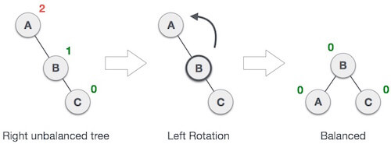

### **2. LL Rotation**

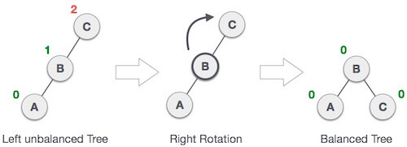

### AVL Rotations**3. LR Rotation**

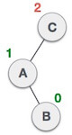

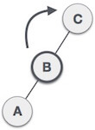

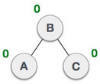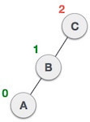

### **4. RL Rotation**

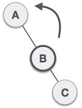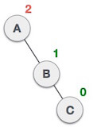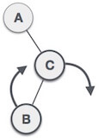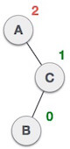



### **Q: Construct an AVL tree having the following elements**

**H, I, J, B, A, E, C, F, D, G, K, L**

1. **Insert H, I, J**

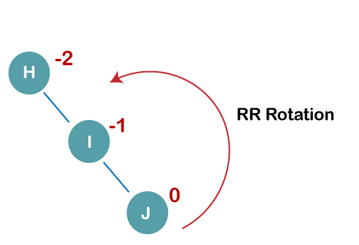

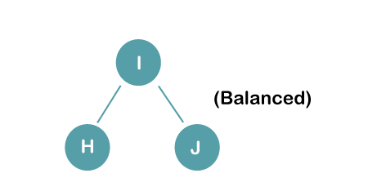

1. 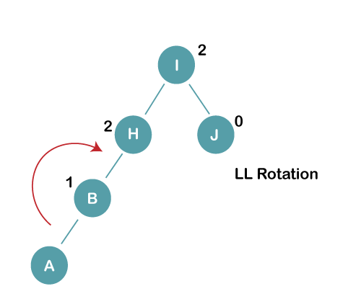**Insert B, A**

**The resultant balance tree is:**

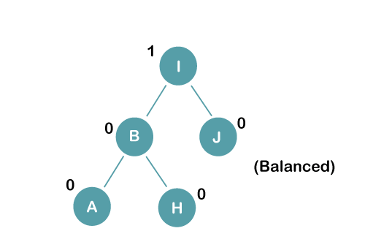

1. **Insert E**

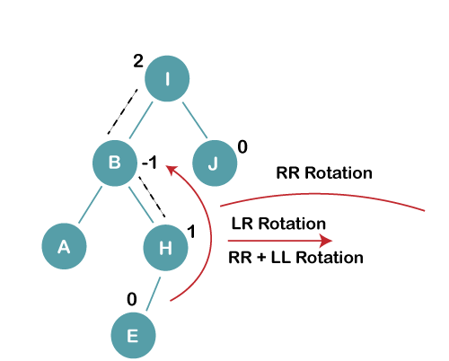

**3 a) We first perform RR rotation on node B**

**The resultant tree after RR rotation is:**

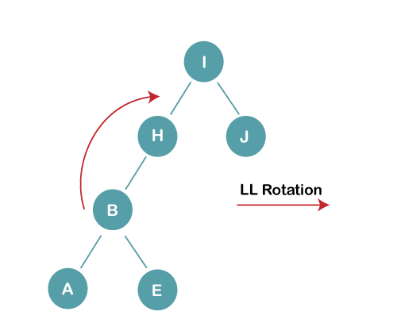

**3b) We first perform LL rotation on the node I**

**The resultant balanced tree after LL rotation is:**

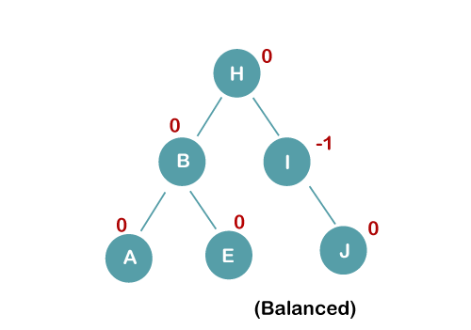

**4. Insert C, F, D**

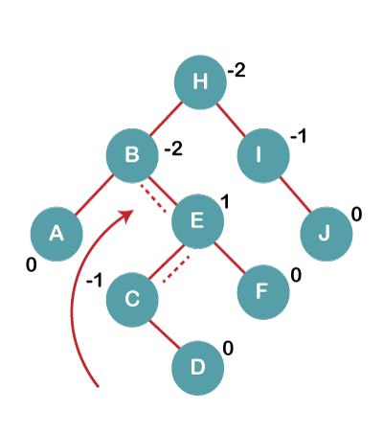

**4a) We first perform LL rotation on node E**

**The resultant tree after LL rotation is:**

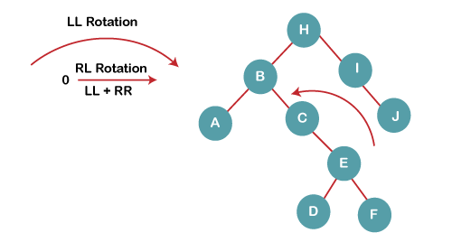

**4b) We then perform RR rotation on node B**

**The resultant balanced tree after RR rotation is:**

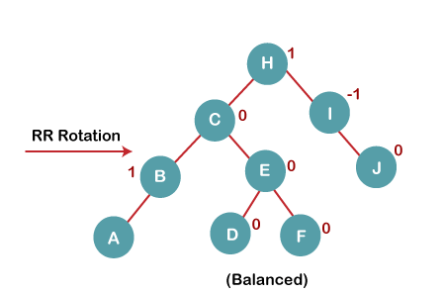

1. **Insert G**

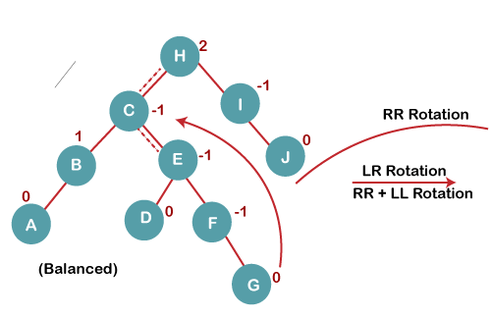

**5 a) We first perform RR rotation on node C**

**The resultant tree after RR rotation is:**

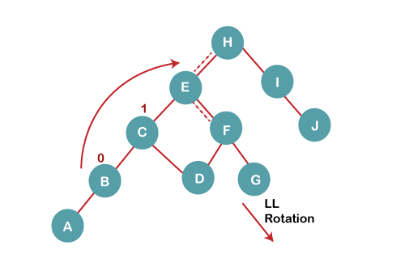

**5 b) We then perform LL rotation on node H**

**The resultant balanced tree after LL rotation is:**

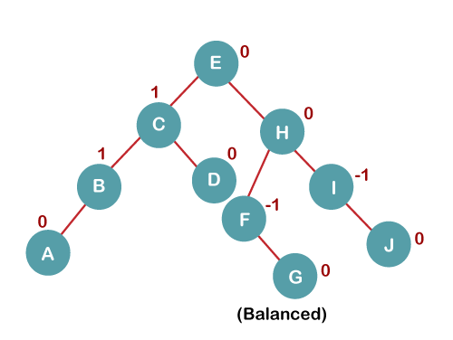

**6. Insert K**

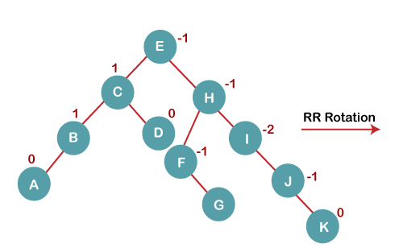

**The resultant balanced tree after RR rotation is:** 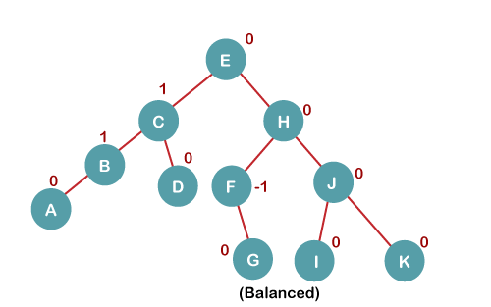

**Program Implementation**

// AVL tree implementation in C++

#include <iostream>

using namespace std;

class Node {

public:

int key;

Node *left;

Node *right;

int height;

};

int max(int a, int b);

// Calculate height

int height(Node *N) {

if (N == NULL)

return 0;

return N->height;

}

int max(int a, int b) {

return (a > b) ? a : b;

}

// New node creation

Node *newNode(int key) {

Node *node = new Node();

node->key = key;

node->left = NULL;

node->right = NULL;

node->height = 1;

return (node);

}

// Rotate right

Node *rightRotate(Node *y) {

Node *x = y->left;

Node *T2 = x->right;

x->right = y;

y->left = T2;

y->height = max(height(y->left),

height(y->right)) +

1;

x->height = max(height(x->left),

height(x->right)) +

1;

return x;

}

// Rotate left

Node *leftRotate(Node *x) {

Node *y = x->right;

Node *T2 = y->left;

y->left = x;

x->right = T2;

x->height = max(height(x->left),

height(x->right)) +

1;

y->height = max(height(y->left),

height(y->right)) +

1;

return y;

}

// Get the balance factor of each node

int getBalanceFactor(Node *N) {

if (N == NULL)

return 0;

return height(N->left) -

height(N->right);

}

// Insert a node

Node *insertNode(Node *node, int key) {

// Find the correct postion and insert the node

if (node == NULL)

return (newNode(key));

if (key < node->key)

node->left = insertNode(node->left, key);

else if (key > node->key)

node->right = insertNode(node->right, key);

else

return node;

// Update the balance factor of each node and

// balance the tree

node->height = 1 + max(height(node->left),

height(node->right));

int balanceFactor = getBalanceFactor(node);

if (balanceFactor > 1) {

if (key < node->left->key) {

return rightRotate(node);

} else if (key > node->left->key) {

node->left = leftRotate(node->left);

return rightRotate(node);

}

}

if (balanceFactor < -1) {

if (key > node->right->key) {

return leftRotate(node);

} else if (key < node->right->key) {

node->right = rightRotate(node->right);

return leftRotate(node);

}

}

return node;

}

// Node with minimum value

Node *nodeWithMimumValue(Node *node) {

Node *current = node;

while (current->left != NULL)

current = current->left;

return current;

}

// Delete a node

Node *deleteNode(Node *root, int key) {

// Find the node and delete it

if (root == NULL)

return root;

if (key < root->key)

root->left = deleteNode(root->left, key);

else if (key > root->key)

root->right = deleteNode(root->right, key);

else {

if ((root->left == NULL) ||

(root->right == NULL)) {

Node *temp = root->left ? root->left : root->right;

if (temp == NULL) {

temp = root;

root = NULL;

} else

*root = *temp;

free(temp);

} else {

Node *temp = nodeWithMimumValue(root->right);

root->key = temp->key;

root->right = deleteNode(root->right,

temp->key);

}

}

if (root == NULL)

return root;

// Update the balance factor of each node and

// balance the tree

root->height = 1 + max(height(root->left),

height(root->right));

int balanceFactor = getBalanceFactor(root);

if (balanceFactor > 1) {

if (getBalanceFactor(root->left) >= 0) {

return rightRotate(root);

} else {

root->left = leftRotate(root->left);

return rightRotate(root);

}

}

if (balanceFactor < -1) {

if (getBalanceFactor(root->right) <= 0) {

return leftRotate(root);

} else {

root->right = rightRotate(root->right);

return leftRotate(root);

}

}

return root;

}

// Print the tree

void printTree(Node *root, string indent, bool last) {

if (root != nullptr) {

cout << indent;

if (last) {

cout << "R----";

indent += " ";

} else {

cout << "L----";

indent += "| ";

}

cout << root->key << endl;

printTree(root->left, indent, false);

printTree(root->right, indent, true);

}

}

int main() {

Node *root = NULL;

root = insertNode(root, 33);

root = insertNode(root, 13);

root = insertNode(root, 53);

root = insertNode(root, 9);

root = insertNode(root, 21);

root = insertNode(root, 61);

root = insertNode(root, 8);

root = insertNode(root, 11);

printTree(root, "", true);

root = deleteNode(root, 13);

cout << "After deleting " << endl;

printTree(root, "", true);

}